**DA ASSIGNMENT 2**

1.DONUT CHART

2. AREA CHART

3. TEXT TABLE

4. HIGHLIGHTED TABLE

5.WORD CLOUD

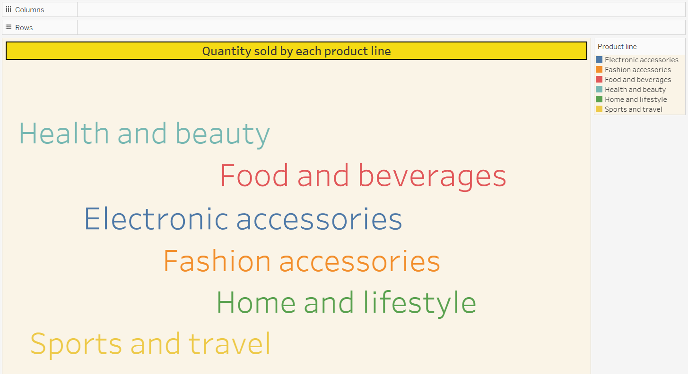

6. FUNNEL CHART

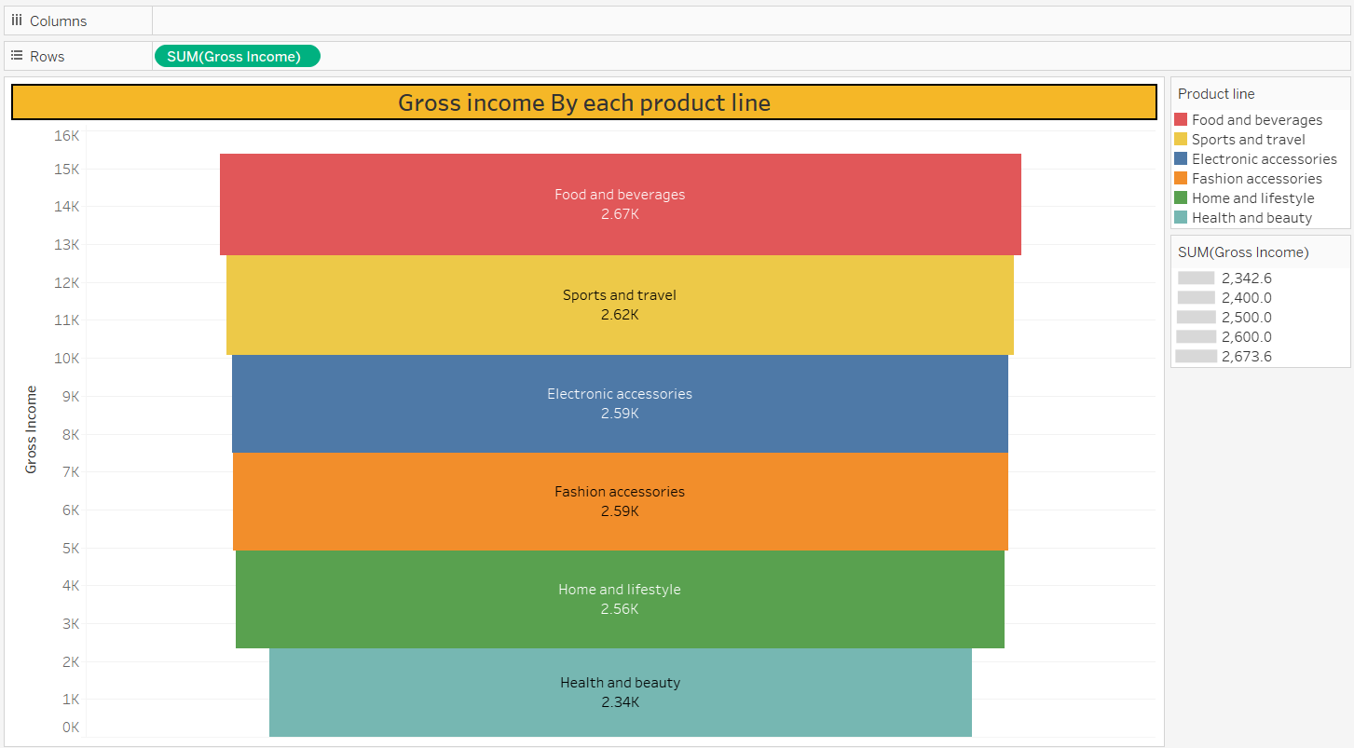

7.WATERFALL CHART

